Assignment 5
Brian Batinchok
Ian Vigrass
Ryon Riley
Alex Lorenzo
Jesse Lambert
Edgar Castellanos

- Step 1

Router A (Interface g 0/0 configuration)
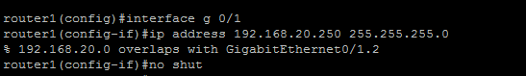

Router B (Interface g 0/0 configuration) 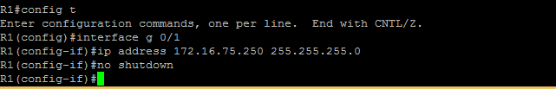

- Step 2

Router A name configuration
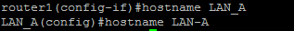

Router B name configuration
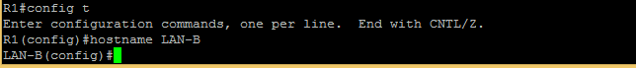

- Step 3

Router A serial 0/0/0 configuration
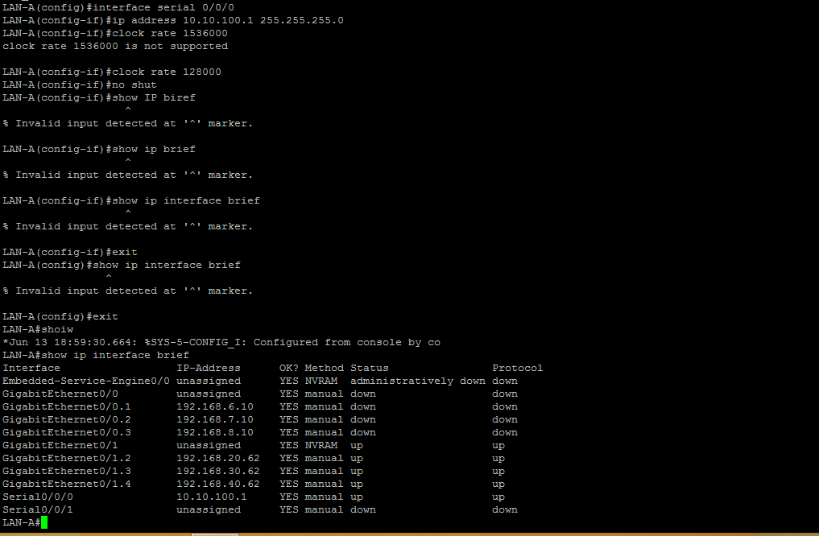

Router B serial 0/0/1 port configuration
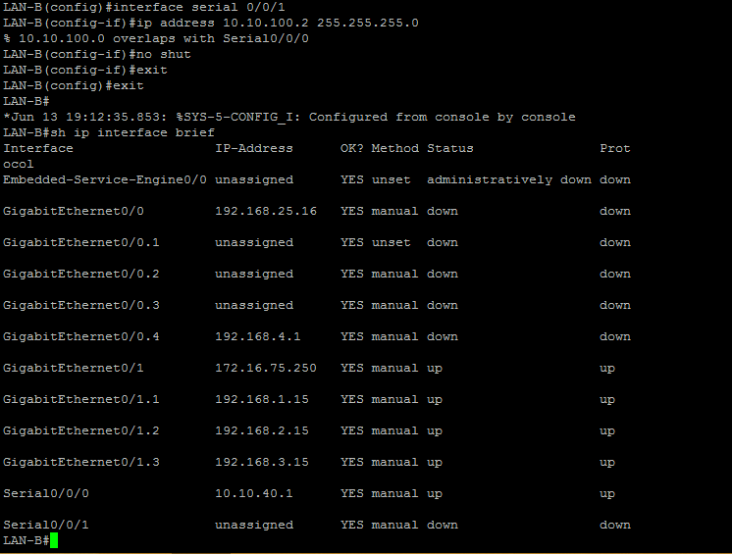

- Step 4

Router A ip route configuration
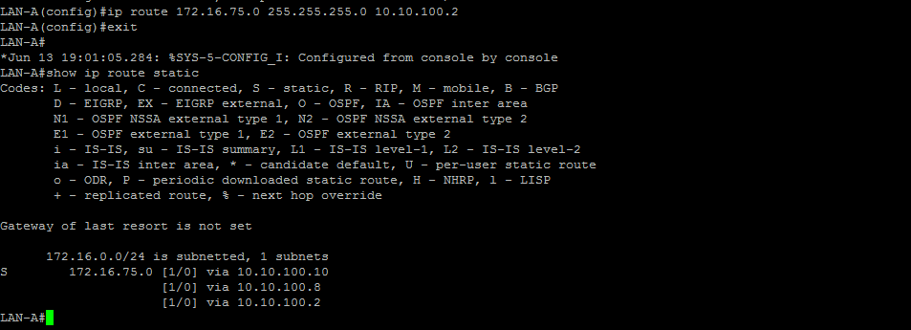

Router B ip route configuration
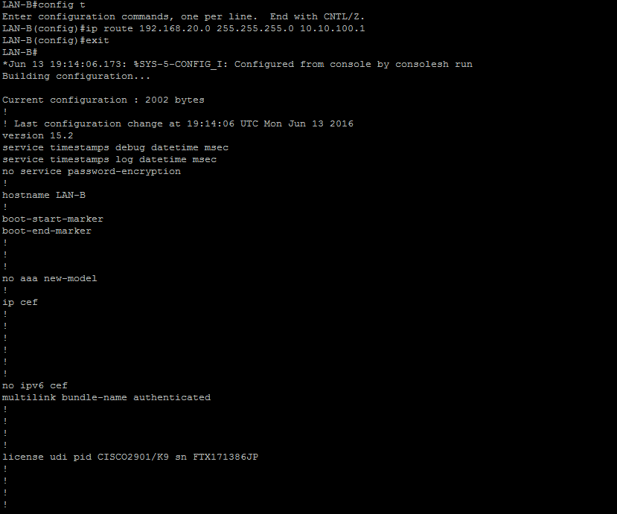
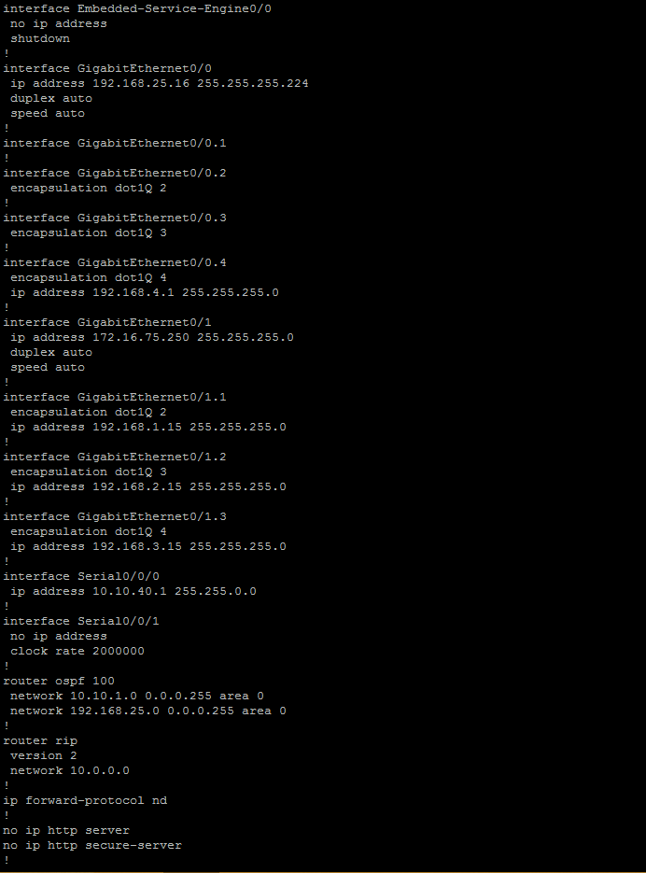
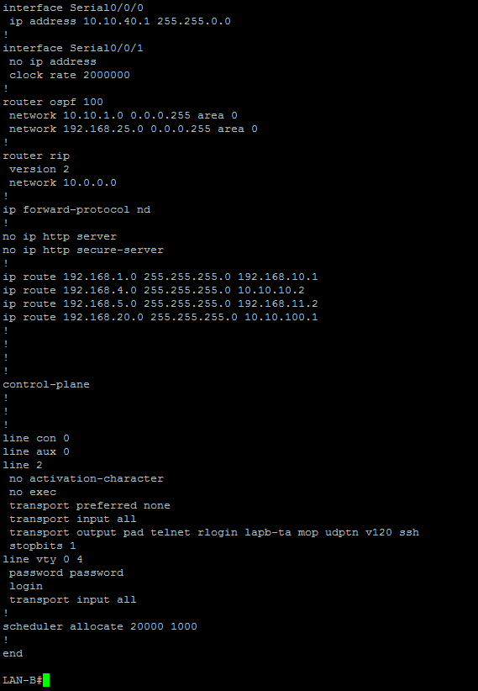
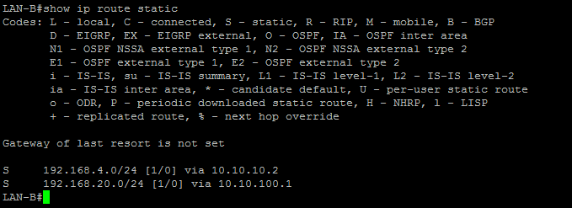

- Step 6

LAN A ping
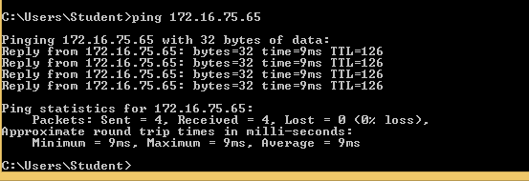

LAN B ping
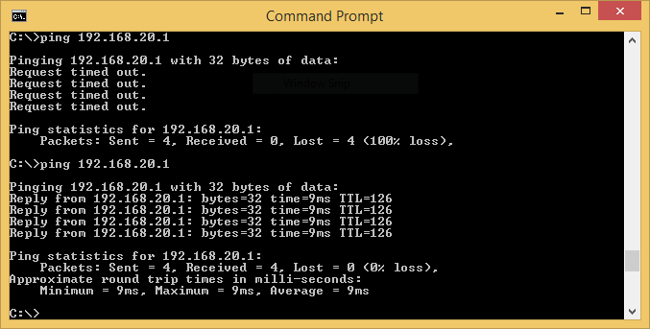

- Step 7

Router A tracert
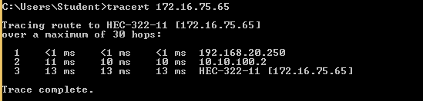

Router B tracert
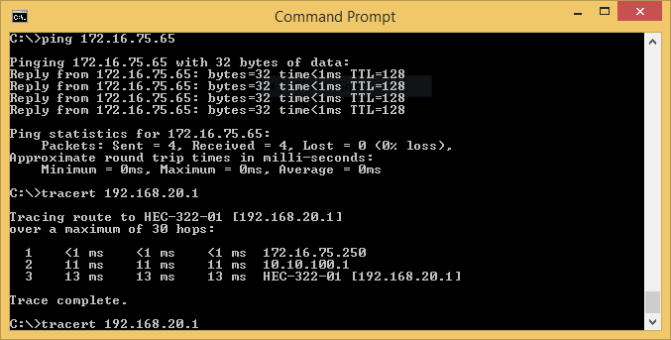

- Step 8

Router A Password Configuration
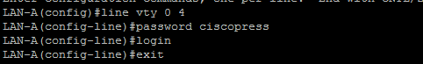

- Step 9
Router A: Show ip route
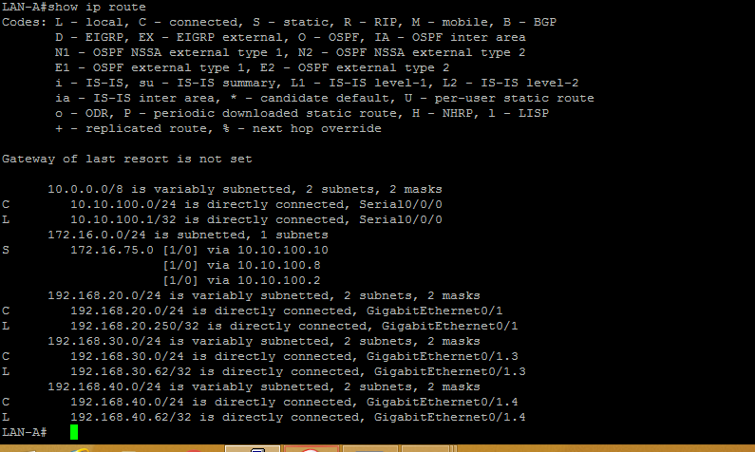

- Step 10

Router A: Save router-configuration
